**CS-114 - Fundamental of Programing**

Lab Manual # 04

**Course Instructor:** Khawaja Fahad Iqbal

**Lab Instructor:** Muhammad Affan

**Student Name:** Muhammad Talha Kashif

**CMS ID:** 454135

#include<iostream>

using namespace std;

HOME TASK 1

int main() {

int result,num;

for(num=1;num<=150;num++)

{

result=num%10;

if(result==0)

{

continue;

}

cout<<num<<" ";

}

return 0;

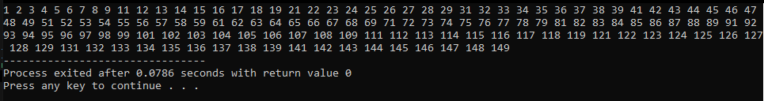}

#include<iostream>

using namespace std;

int main() {

HOME TASK 2

int num1,num2,digit,sum;

cout<<"Enter a number: ";

cin>>num1;

num2=num1;

sum=0;

while(num1>0)

{

digit=num1%10;

num1=num1/10;

sum=sum+digit;

}

cout<<"The sum of digits of "<<num2<<" is: "<<sum<<endl;

return 0;

}

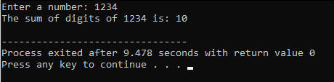

#include<iostream>

using namespace std;

HOME TASK 3

int main() {

int num,i,r;

cout<<"Enter a number: ";

cin>>num;

if(num==0||num==1)

{

cout<<num<<" is not a prime number"<<endl;

}

for(i=2;i<num;i++)

{

r=num%i;

if(r==0)

{

cout<<num<<" is not a prime number"<<endl;

break;

}

else

{

cout<<num<<" is a prime number"<<endl;

break;

}

}

return 0;



